**Bhusawal Arts, Science & P. O. Nahata Commerce College, Bhusawal.**

**LIST OF COLLEGE COMMITTEES : 2020-2021**

The undersigned is pleased to appoint Chairman and Members of various committees for the year 2020-2021 All are requested to do the needful for effective execution of work related to the respective committee.

|  |  |  |
| --- | --- | --- |
| **Sr.No** | **COMMITTEE** | **MEMBER** |
| 1 | GRIEVANCE REDRESSAL CELL FOR STAFF | Prin. Dr.Mrs.M.V.Waykole, **Chairman** |
| Vice-Prin.Prof. Dr. S. V. Patil. |
| Vice-Prin. Prof. Dr. B. H. Barhate. |
| Vice-Prin. Prof. Dr. A. D. Goswami.. |
| Vice-Prin. Prof. Dr. N. E. Bhangale |
| Prof. E.G. Nehate. |
| Prof.Dr. Vidya A. Patil, |
| Inch. Regst.Rekha. M. Barhate. |
| Inch.O.S. Sh. B. V. Tayade. |
| 2 | ANTI RAGGING | Prin. Dr.Mrs.M.V.Waykole, **Chairman** |
| Vice-Prin.Prof. Dr. S. V. Patil. |
| Prof.Dr. Smita S. Chaudhari, |
| Prof. Dr. Gouri M. Patil |
| Prof. D. N. Patil. |
| Inch. Regst.Rekha. M. Barhate. |
| Inch.O.S. Sh. B. V. Tayade. |
| 3 | INTERNAL QUALITY ASSURANCE CELL (IQAC) | Prin. Dr. M.V. Waykole **Chairperson** |
| Mr. Mohan Phalak Member from Management |
| Dr. B. H. Barhate IQAC Coordinator |
| Dr. S. V. Patil Member |
| Prof. S. N. Nehete Member |
| Prof. V. G. Kochure Member |
| Prof. R. R. Patil Member |
| Dr. A. D. Goswami Member |
| Dr. S. P. Zanke Member |
| Dr. N. E. Bhangale Member |
| Dr. A. V. Upadhyay Member |
| Dr. S. D. Yeole Member |
| Mrs. Shobha Patil External Member |
| Mr. Mukesh Agrawal External Member |
| Dr. Ketan Mahajan External Member |
| Mr.Rajesh Chaudhari Industrialist |
| Smt. Rekha Barhate Administrative Officer |
| Shri. Bhagvan Tayade Administrative Officer |
| Shri. Mukesh Firke Administrative Officer |
| Shri Ashish Chaudhari Librarian |
| 4 | CO-ORDINATION | Prof. Dr. S.V. Patil, **Chairman** |
| Prof. Dr. G. R. Wani. |
| Prof. Dr.R.S.Nadekar. |
| Prof. A. P. Navghare. |
| Prof. Dr. P.K.Patil. |
| 5 | Women Grievance Redressal cell  Vishakha Committee | Prof. Dr. Smita S. Chaudhari, **Co-ordinator** |
| Prof. Dr. Vidya A. Patil. |
| Prof. Dr. Gouri M. Patil. |
| Prof. Dr. Mamtaben C. Patil. |
| Prof. Dr. Rashmi R. Sharma, |
| Prof. Dr. Swati Phalak |

|  |  |  |
| --- | --- | --- |
| 6 | COMMITTEE FOR RESEARCH DEVELOPMENT AND CONSULTANCY SERVICES | Prof. Dr. S. D. Yeole. **Chairman.** |
| Prof. Dr. D. K. Hivrale |
| Prof. Dr. K. K. Ahire. |
| Prof. Dr. Rashmi R. Sharma. |
| Prof. Dr. K. A. Warke. |
| Prof. Dr. Umesh Fegade |
| Prof. Dr. M.J. Jadhav. |
| 7 | PLACEMENT | Prof. Dr. Majoj Jadhav, **Chairman** |
| Prof. R. R. Patil |
| Prof. Dr. G. R. Wani |
| Prof. K. P. Patil. |
| Prof. Dr. M. N. Patil |
| Prof. Dr. V.N. Mahire. |
| Prof. Dr. Umesh Fegade |
| Prof. Smita Bendale |
| 8 | COMMUNICATION SKILL | Prof. Dr. Rashmi R. Sharma, **Chairman.** |
| Prof. Dr. P.A. Ahire. |
| Prof. Dr. K. A. Warke. |
| Prof. K. P. Patil. |
| Prof . V. A. Salunke. |
| Prof. Dr. M.J. Jadhav. |
| 9 | ACADEMIC PERFORMANCE INDICATOR | Prof. Dr. K. K. Ahire, **Chairman** |
| Prof. Dr. P. A. Ahire. |
| Prof. Dr. N. S. Patil. |
| Prof. Dr. D. M. Tekade. |
| Prof. Dr. S.D.Yeole. |
| 10 | COMMITTEE FOR SELF APPRAISAL | Prof. R. R. Patil, **Chairman.** |
| Prof. Dr. D.M. Tekade. |
| Prof. V. P. Ladhe. |
| Prof. Bhushan Chaudhari |
| Inch. Regst.Rekha. M. Barhate. |
| 11 | STUDENTS’ FEEDBACK | Prof. Dr. S. P. Zanke, **Chairman** |
| Prof. K.P.Patil |
| Prof. A. P. Navghare. |
| Prof. Dr. V.N. Mahire. |
| Prof. Harshal Patil |
| Prof. Dr. Swati Phalak |
| Prof. Bhushan Chaudhari |
| Prof. Sachin Kolte |
| 12 | STAFF & STUDENTS WELFARE COMMITTEE | Prof.Dr. P. A. Ahire, **Chairman.** |
| Prof. Dr. Gouri. M. Patil |
| Prof. P. H. Ingole. |
| Prof. S. K. Rathod |
| Prof. Dr. S. D. Yeole. |
| Prof. Smita Bendale. |

|  |  |  |  |
| --- | --- | --- | --- |
| 13 | ANNUAL REPORT | | Prof. Dr. Vidya A. Patil. **Chairman.** |
| Prof. Dr. G.R. Wani. |
| Prof. Dr. R. S. Nadekar |
| Prof. Dr. Mamtaben C. Patil. |
| Prof. Dr. V. N. Mahire |
| Prof. Dr. M.J. Jadhav. |
| Prof. Chandrakant Sarode |
| Prof. Smita Bendale. |
| Inch. Regst.Rekha. M. Barhate. |
| Inch.O.S. Sh. B. V. Tayade. |
| Jr.Clerk Mrs. Prajakta B. Bagul. |
| Jr.Clerk G. D. Avhad. |
| 14 | ANNUAL CALENDER | | Prof. Dr. P. A. Ahire, **Chairman.** |
| Prof. D. N. Patil |
| 15 | MAGAZINE | | Prof. Dr. K. K. Ahire. **Chairman.** |
| Prof. P. A. Ahire. |
| Prof. Dr. J. F. Patil |
| Prof. D. N. Patil |
| Prof. S.K. Rathod. |
| Prof. Dr. M. N. Patil. |
| Prof. Smita Bendale |
| 16 | | LIBRARY | Prof. Dr. A. D. Goswami. **Chairman.** |
| Prof. R. R. Patil. |
| Prof. Dr. D. K. Hiwarale |
| Prof. P. K. Patil |
| Prof. Dr. Gouri Patil |
| Prof. A. P. Navghare |
| Shri. A. V. Chaudhari. |
| Prof. V. A. Solanke. |
| 17 | | GYMKHANA | Prof. Dr. A. V. Upadhyay , **Chairman.** |
| Prof. S. T. Dhum. |
| Prof. S. K. Rathod. |
| Prof. P.H. Ingole. |
| Prof. Harshal V. Patil |
| Prof. Dr. M.J. Jadhav. |
| 18 | | PRIZE DISTRIBUTION | Prof. Dr. S.V. Patil, **Chairman.** |
| Prof. S. T. Dhum. |
| Prof.Dr. N. S. Patil. |
| Prof. Dr. P. K. Patil. |
| Prof. Dr. Rashmi R. Sharma. |
| Prof. Dr. M. J. Jadhav. |
| 19 | | UGC GRANTS – Scheme, Proposal | Prof. Dr. B. H. Barhate, **Chairman.** |
| Prof. R. R. Patil. |
| Prof. Dr. S.D. Yeole. |
| Prof. D. N. Patil. |
| Prof. Dr. Rashmi R. Sharma. |
| 20 | | CAMPUS, GARDEN, CANTEEN & VEHICLE STAND DEVELOPMENT | Prof. Dr. S. V. Patil. **Chairman.** |
| Prof. Dr. B. H. Barhate |
| Prof. Dr. A. D. Goswami |
| Prof. Dr. N. E. Bhangale |
| Prof. Dr. A. V. Upadhyay |
| Prof. Dr. M. J. Jadhav. |
| O.S Shri. B. V. Tayade |
| Shri. Sandip S. Patil |

|  |  |  |
| --- | --- | --- |
| 21 | COLLEGE EXAMINATIONS | Prof. Dr. A. D. Goswami, **Chairman.** |
| Prof. Dr. B. H. Barhate, **Chairman.** |
| Prof.Dr. N. E. Bhangale, **Chairman.** |
| Prof. V. G. Kochure |
| Prof. R. R. Patil |
| Prof. Dr. N. S. Patil. |
| Prof. Dr. P. K. Patil |
| Prof. Dr. R. S. Nadekar. |
| Prof. S. K. Rathod |
| 22 | GRIEVENCE REDRESSAL CELL for Students  (Decipline Committee) | Prof. Anil Hiwale, **Chairman.** |
| Prof. Dr. Vidya A. Patil. |
| Prof. Dr. Smita S. Chaudhari. |
| Prof. Dr. R. S. Nadekar. |
| Prof. D. N. Patil. |
| Prof. Dr. P. K. Patil |
| Prof. Dr. A. V. Upadhyay. |
| Prof. Dr. K. A. Warke. |
| Prof. Dr. D. M. Tekade. |
| 23 | ALLUMNI COMMITTEE | Prof. Prashant Patil, **Chairman.** |
| Prof. D. N. Patil |
| Prof. K. P. Patil |
| Prof. Dr. K. A. Warke. |
| Prof. Harshal Patil. |
| Prof. Sangita Bhirud |
| 24 | COMPUTER SUPPORT & SERVICES | Prof. Dr. G. R. Wani, **Chairman.** |
| Prof. Dr. Gouri Patil. |
| Prof. Harshal Patil |
| Prof. Dr. Swati Phalak |
| Shri. Jayant Bendale |
| Shri. K. V. Narkhede. |
| 25 | STAFF ACADEMY | Prof. E. G. Nehete. **Chairman.** |
| Prof. Dr. K. K. Ahire. |
| Prof. S. K. Rathod. |
| Prof. A. P. Navghare. |
| Prof.Dr. M. J. Jadhav. |
| 26 | CAREER GUIDANCE (Guidance for G.K. & Competitive Exam.) & COUNSELLING CELL | Prof. Dr. D. M. Tekade, **Chairman.** |
| Prof. Dr. Y.K. Chaudhari. |
| Prof. E.G.Nehate. |
| Prof. V. D. Jain. |
| Prof. D.N.Patil.. |
| Prof. P. H. Ingole. |
| Prof. Dr. Gouri M. Patil. |
| Prof. Dr. R. S. Nadekar. |
| Prof. Chandrakant Sarode |
| Prof. Dr. V. N. Mahire. |
| 27 | PERSONLITY DEVELOPMENT CELL | Prof. Dr. Rashmi Sharma, **Chairman.** |
| Prof. Dr. G. R. Wani. |
| Prof. Dr. Raghavdas Gorle.. |
| Prof. V. P. Ladhe. |
| Prof. Dr. R. S. Nadekar. |
| Prof. P. H. Ingole. |

|  |  |  |  |  |
| --- | --- | --- | --- | --- |
| 28 | | | COUNCELLING for ADMISSIONS | Prof. Dr. A. D. Goswami **Chairman.** |
| Prof. Dr. B. H. Barhate. **Science** |
| Prof. Dr. Y. K. Chaudhari |
| Prof. Dr. Vidya A. Patil. |
| Prof. A. P. Navghare. |
| Prof. Dr. Gouri M. Patil. |
| Prof. Dr. M. J. Jadhav. |
| Prof. Dr. V. N. Mahire. |
| Prof. Sangita Bhirud |
| Prof. Dr. N. E. Bhangale **Commerce** |
| Prof. Dr. P. K. Patil |
| Prof. Dr. Mamtaben C. Patil. |
| Prof. K. P. Patil |
| Prof. Bhushan Chaudhari |
| Prof. Dr. S. P. Zanke. **Arts** |
| Prof. Anil Hiwale |
| Prof. Dr. M. N. Patil |
| Prof. S. K. Rathod. |
| Prof. V. A. Solanke. |
| Prof. Dr. R. S. Nadekar. |
| 29 | | | TIME TABLE | Prof. Dr. G. R. Wani., **Chairman.** |
| Prof. Dr. B. H. Barhate. |
| Prof. Dr. A. D. Goswami |
| Prof. N. E. Bhangale |
| Prof. Dr. D. K. Hiwarale. |
| Prof. V. G. Kochuare. |
| Prof. Dr. R. S. Nadekar |
| Prof. S. K. Rathod. |
| Prof. A. P. Navghare. |
| Prof. Dr. Rashmi S. Sharma. |
| Prof. Dr. S. D. Yeole. |
| Mrs. Prajakta B. Bagul. |
| 30 | STUDENT’S COUNCIL | | Prof. Dr. A. D. Goswami, **Chairman.** |
| Prof. Dr. S. V. Patil. |
| Prof. Dr. B. H. Barhate. |
| Prof. Dr. N. E. Bhangale |
| Prof. V. D. Jain |
| Prof. R. R. Patil |
| Prof. Dr. N. S. Patil. |
| Prof. Dr. P. A. Ahire |
| Prof. Dr. Smita S. Chaudhari |
| Prof. Dr. Vidya A. Patil |
| Prof. S. T. Dhum. |
| Prof. Dr. P. K. Patil. |
| Prof. D. N. Patil |
| Prof. Dr. A. V. Upadhyay. |
| Prof. Dr. K. A. Warke |
| Prof. Dr. S. D. Yeole. |
| Prof. Anil Hiwale. |

|  |  |  |
| --- | --- | --- |
| 31 | LADIES WELFARE | Prof. Dr. Gouri M Patil. **Chairman.** |
| Prof. Dr. Smita S. Chaudhari, |
| Prof. Dr. Vidya A. Patil |
| Prof. Dr. Rashmi R. Sharma. |
| Prof. Dr. Swati Phalak |
| Prof. Sangita Bhirud |
| Prof. Poonam Mahajan |
| 32 | ARTS CIRCLE | Prof. Dr. N. S. Patil, **Chairman.** |
| Prof. Dr. K. K. Ahilre |
| Prof. V. D. Jain |
| Prof. E. G. Nehete. |
| Prof. Dr. Vidya A. Patil |
| Prof. Dr. R. S. Nadekar |
| Prof. S T. Dhum. |
| Prof. S. K. Rathod |
| Prof. Dr. Mamtaben C. Patil |
| Prof. Dr. V. N. Mahire |
| Prof. Rajashri Deshmukh. |
| 33 | LITERARY ASSOCIATION | Prof. D.N. Patil, **Chairman.** |
| Prof. Dr. Rekha P. Gajare, |
| Prof. Dr. S. P. Zanke. |
| Prof. S. K. Rathod. |
| Prof. Dr. M. N. Patil |
| 34 | MENTAL MORAL & SOCIAL SCIENCES ASSOCIATION | Prof. S. K. Rathod **Chairman.** |
| Prof. Dr. Raghavdas Gorle. |
| Prof. V. A. Solanke.. |
| Prof. Dr. D. M. Takade. |
| 35 | PLANNING FORUM | Prof. S.T.Dhum, **Chairman.** |
| Prof. Dr. Raghavdas Gorle. |
| Prof. Dr. Rashmi Sharma. |
| Prof. Dr. K. A. Warke. |
| Prof. V. A. Salunke. |
| 36 | SCIENCE ASSOCIATION | Prof. Dr. G.R.Wani., **Chairman.** |
| Prof. E. G. Nehete |
| Prof. A. H. Patil. |
| Prof. Dr. N.S. Patil. |
| Prof. V. P. Ladhe. |
| Prof. A. P. Navghare |
| Prof. Dr. Gouri M. Patil |
| Prof. Dr. S.D.Yeole. |
| Prof. Dr. V. N. Mahire. |
| Prof. Dr. M. J. Jadhav |
| 37 | COMMERCE ASSOCIATION | Prof. Dr. Mamtaben C. Patil. **Chairman.** |
| Prof. S. T. Dhum. |
| Prof. Dr. Raghavdas Gorle.. |
| Prof. Dr. P.K.Patil. |
| Prof. K. P. Patil |

|  |  |  |
| --- | --- | --- |
| 38 | DEBATING | Prof. Dr. J. F. Patil, **Chairman.** |
| Prof. Dr. Smita Chaudhari. |
| Prof. Dr. R. S. Nadekar |
| Prof. Poonam Mahajan |
| Prof. Purushottam Mahajan |
| 39 | MEDICAL CHECK- UP | Prof. Dr. Rashmi Sharma. **Chairman.** |
| Prof. Dr. N.S.Patil. |
| Prof. Dr. Smita S. Chaudhari. |
| Prof. Dr. P. A. Ahire. |
| Prof. S. T. Dhum. |
| Prof. K. P. Patil. |
| Prof. Dr. A. V. Upadhyay. |
| Prof. P. H. Ingole. |
| Prof. D. N. Patil. |
| Prof. Dr. V. N. Mahire. |
| 40 | RESULT ANALYSIS | Prof. V. D. Jain, **Chairman.** |
| Prof. Dr. K. K. Ahire. |
| Prof. Dr. N. S. Patil. |
| Prof. P. H. Ingole. |
| Prof. K. P. Patil |
| Prof. A. P. Navghare. |
| Prof. V. A. Solunke. |
| Prof. Harshal Patil. |
| Prof. Dr. Umesh Fegade |
| Prof. B. M. Chaudhari. |
| Prof. Archana Bhalerao |
| Prof. Pooja Rathi |
| Prof. Dr. M. J. Jadhav. |
| 41 | VIVEK WAHINI MANDAL | Prof. Dr.R. S. Nadekar, **Chairman.** |
| Prof. S.T.Dhum. |
| Prof. Dr. Gouri Patil. |
| Prof. P. H. Ingole. |
| Prof. Dr. D. M. Tekade. |
| Prof. Smita Bendale. |
| 42 | NATYASHASTRA MANDAL | Shri. Vaibhav Mavle, **Chairman.** |
| Prof. Dr. J. F. Patil |
| Prof. Sangita Bhirud |
| 43 | PUBLICITY | Prof. Dr. J. F. Patil. **Chairman.** |
| Prof. Dr. D. M. Tekade. |
| Prof. K. P. Patil. |
| Prof. Purushottam Mahajan |
| Prof. Prashant Patil |
| Shri. Shankar Patil |
| 44 | ENVIRONMENT EDUCATION | Prof. Dr. Vidya. A. Patil, **Co-ordinator.** |
| Prof. Dr. S. D Yeole. |
| Prof. D. N. Patil. |
| Prof. V. P. Ladhe. |
| Prof. A. P. Navghare. |
| Prof. K. P. Patil |
| Prof. Dr. Gouri Patil |
| Prof. Dr. Umesh Fegade. |

|  |  |  |
| --- | --- | --- |
| 45 | CERTIFICATE COURSES | Prof. Dr. G.R. Wani., **Chairman.** |
| Prof. Dr. Mamtaben C. Patil. |
| Prof. Dr. R. S. Nadekar. |
| Prof. V. A. Solunke |
| Dr. Umesh Fegade |
| Prof. Harshal Patil |
| Dr. M. N. Patil |
| Shri. Vinay Chaudhari |
| Shri. Vaibhav Mavle. |
| 46 | SC/ST Cell | Prof. V. G. Kochure, **Chairman.** |
| Prof. Dr. K. K. Ahire. |
| Prof. Dr. S. P. Zanke. |
| Prof. S. T. Dhum |
| Prof. Dr. R. S. Nadekar. |
| 47 | OBC Cell | Prof. Dr. N. E. Bhangale, **Chairman.** |
| Prof. Dr. N. S. Patil |
| Prof. Dr. Smita S. Chaudhari. |
| Prof. Dr. K. A. Warke. |
| Prof. Dr. S.D. Yeole. |
| 48 | MENTOR-MENTEE COMMITTEE | Prof. Dr. S. P. Zanke, **Chairman.** |
| Prof. S. N. Nehate. |
| Prof. Dr. P. A. Ahire. |
|  | Prof. Dr. P. K. Patil. |
| Prof. V. A. Solanke |
| Prof. K. P. Patil. |
| Prof. Dr. V. N. Mahire. |

All staff members are requested to extend their co-operation in carrying out curricular and extra curricular activities effectively and successfully.

|  |  |  |
| --- | --- | --- |
| **Sr.No** | **COMMITTEE** | **Nodal Officer/Co-ordinator** |
| 1 | **A**ll **I**ndia **S**urvey on **H**igher **E**ducation **(AISHE)** | Prof. Harshal Patil **Nodal Officer** |
| 2 | **N**ational **H**igher **E**ducation **R**esource **C**enter **(NHERC)** |  |
| 3 | **S**chemefor **H**igher **E**ducation **Y**outhfor **A**pprenticeshipand **S**kills **(SHREYAS)** | Prof. Dr. Manoj Jadhav **Co-ordinator** |
| 4 | **Swayam** | Prof. Dr. Gouri Patil **Co-ordinator** |
| 5 | Unnat Bharat Abhiyan | Prof. Dr. N. S. Patil **Nodal Officer** |
| 6 | Voter Card | Prof. Dr. D. M. Tekade **Nodal Officer** |
| 7 | e-Suvidha | Prof. Dr. G. R. Wani **Co-ordinator** |

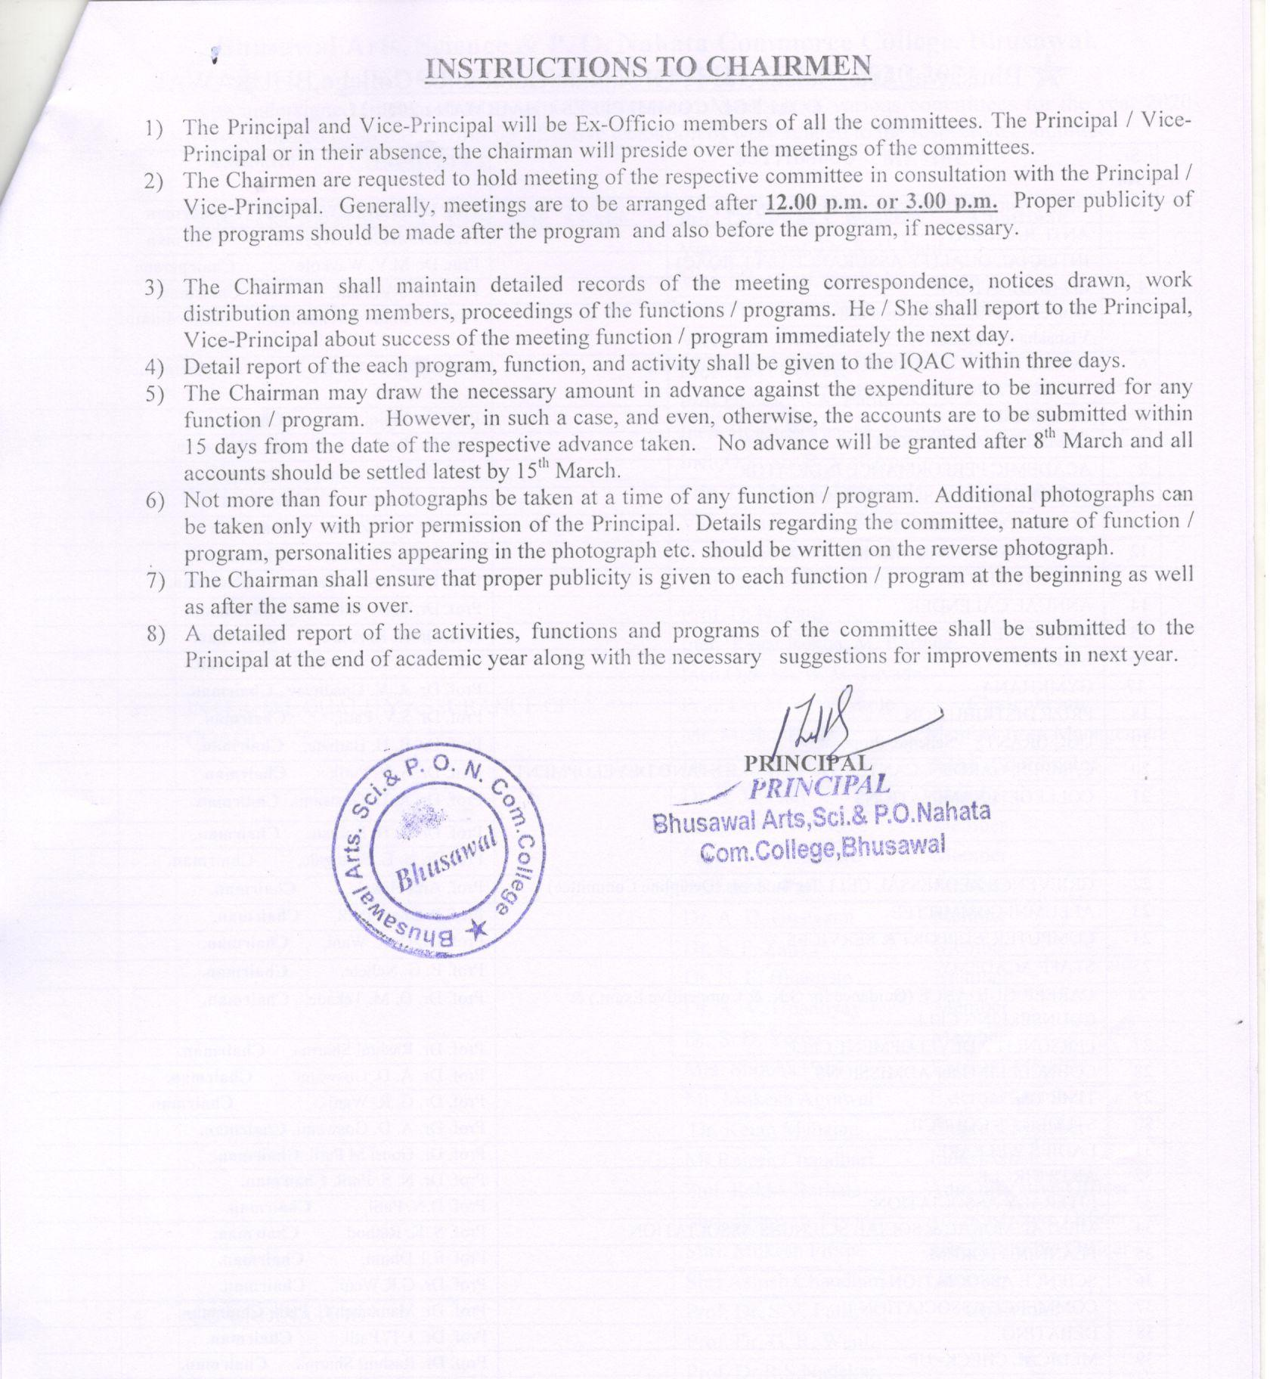**INSTRUCTIONS TO CHAIRMEN**

1. The Principal and Vice-Principal will be Ex-Officio members of all the committees. The Principal / Vice-Principal or in their absence, the chairman will preside over the meetings of the committees.
2. The Chairmen are requested to hold meeting of the respective committee in consultation with the Principal / Vice-Principal. Generally, meetings are to be arranged after **12.00 p.m. or 3.00 p.m.** Proper publicity of the programs should be made after the program and also before the program, if necessary.

1. The Chairman shall maintain detailed records of the meeting correspondence, notices drawn, work distribution among members, proceedings of the functions / programs. He / She shall report to the Principal, Vice-Principal about success of the meeting function / program immediately the next day.
2. Detail report of the each program, function, and activity shall be given to the IQAC within three days.
3. The Chairman may draw the necessary amount in advance against the expenditure to be incurred for any function / program. However, in such a case, and even, otherwise, the accounts are to be submitted within 15 days from the date of the respective advance taken. No advance will be granted after 8th March and all accounts should be settled latest by 15th March.
4. Not more than four photographs be taken at a time of any function / program. Additional photographs can be taken only with prior permission of the Principal. Details regarding the committee, nature of function / program, personalities appearing in the photograph etc. should be written on the reverse photograph.
5. The Chairman shall ensure that proper publicity is given to each function / program at the beginning as well as after the same is over.
6. A detailed report of the activities, functions and programs of the committee shall be submitted to the Principal at the end of academic year along with the necessary suggestions for improvements in next year.

**PRINCIPAL**

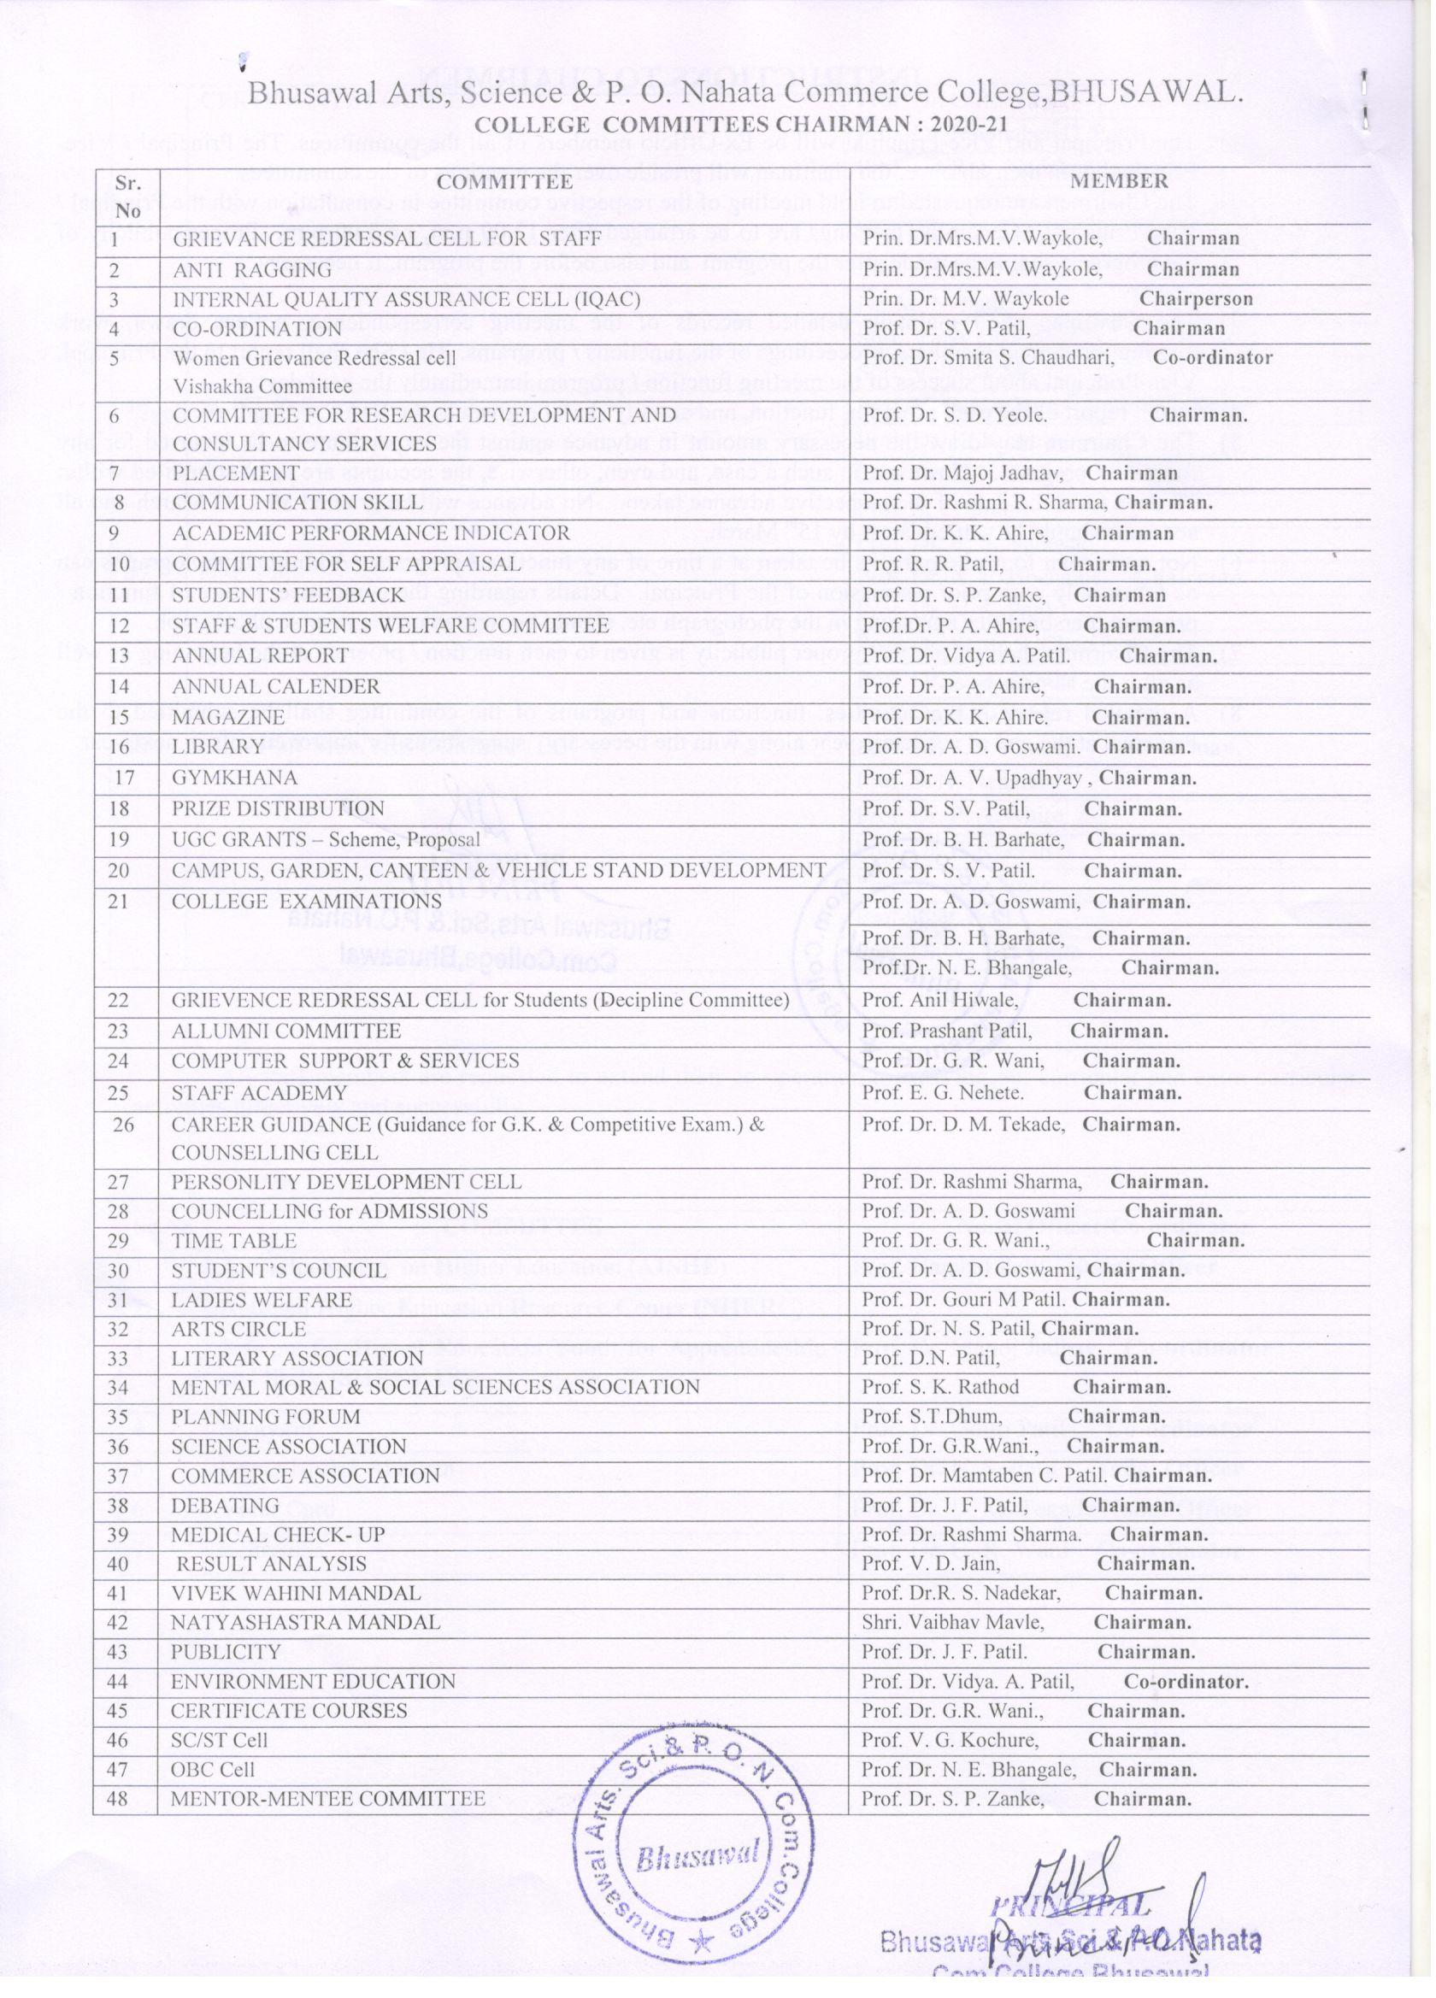

Bhusawal Arts, Science & P. O. Nahata Commerce College,BHUSAWAL.

**COLLEGE COMMITTEES CHAIRMAN : 2020-21**

|  |  |  |
| --- | --- | --- |
| **Sr.**  **No** | **COMMITTEE** | **MEMBER** |
| 1 | GRIEVANCE REDRESSAL CELL FOR STAFF | Prin. Dr.Mrs.M.V.Waykole, **Chairman** |
| 2 | ANTI RAGGING | Prin. Dr.Mrs.M.V.Waykole, **Chairman** |
| 3 | INTERNAL QUALITY ASSURANCE CELL (IQAC) | Prin. Dr. M.V. Waykole **Chairperson** |
| 4 | CO-ORDINATION | Prof. Dr. S.V. Patil, **Chairman** |
| 5 | Women Grievance Redressal cell  Vishakha Committee | Prof. Dr. Smita S. Chaudhari, **Co-ordinator** |
| 6 | COMMITTEE FOR RESEARCH DEVELOPMENT AND CONSULTANCY SERVICES | Prof. Dr. S. D. Yeole. **Chairman.** |
| 7 | PLACEMENT | Prof. Dr. Majoj Jadhav, **Chairman** |
| 8 | COMMUNICATION SKILL | Prof. Dr. Rashmi R. Sharma, **Chairman.** |
| 9 | ACADEMIC PERFORMANCE INDICATOR | Prof. Dr. K. K. Ahire, **Chairman** |
| 10 | COMMITTEE FOR SELF APPRAISAL | Prof. R. R. Patil, **Chairman.** |
| 11 | STUDENTS’ FEEDBACK | Prof. Dr. S. P. Zanke, **Chairman** |
| 12 | STAFF & STUDENTS WELFARE COMMITTEE | Prof.Dr. P. A. Ahire, **Chairman.** |
| 13 | ANNUAL REPORT | Prof. Dr. Vidya A. Patil. **Chairman.** |
| 14 | ANNUAL CALENDER | Prof. Dr. P. A. Ahire, **Chairman.** |
| 15 | MAGAZINE | Prof. Dr. K. K. Ahire. **Chairman.** |
| 16 | LIBRARY | Prof. Dr. A. D. Goswami. **Chairman.** |
| 17 | GYMKHANA | Prof. Dr. A. V. Upadhyay , **Chairman.** |
| 18 | PRIZE DISTRIBUTION | Prof. Dr. S.V. Patil, **Chairman.** |
| 19 | UGC GRANTS – Scheme, Proposal | Prof. Dr. B. H. Barhate, **Chairman.** |
| 20 | CAMPUS, GARDEN, CANTEEN & VEHICLE STAND DEVELOPMENT | Prof. Dr. S. V. Patil. **Chairman.** |
| 21 | COLLEGE EXAMINATIONS | Prof. Dr. A. D. Goswami, **Chairman.** |
| Prof. Dr. B. H. Barhate, **Chairman.** |
| Prof.Dr. N. E. Bhangale, **Chairman.** |
| 22 | GRIEVENCE REDRESSAL CELL for Students (Decipline Committee) | Prof. Anil Hiwale, **Chairman.** |
| 23 | ALLUMNI COMMITTEE | Prof. Prashant Patil, **Chairman.** |
| 24 | COMPUTER SUPPORT & SERVICES | Prof. Dr. G. R. Wani, **Chairman.** |
| 25 | STAFF ACADEMY | Prof. E. G. Nehete. **Chairman.** |
| 26 | CAREER GUIDANCE (Guidance for G.K. & Competitive Exam.) & COUNSELLING CELL | Prof. Dr. D. M. Tekade, **Chairman.** |
| 27 | PERSONLITY DEVELOPMENT CELL | Prof. Dr. Rashmi Sharma, **Chairman.** |
| 28 | COUNCELLING for ADMISSIONS | Prof. Dr. A. D. Goswami **Chairman.** |
| 29 | TIME TABLE | Prof. Dr. G. R. Wani., **Chairman.** |
| 30 | STUDENT’S COUNCIL | Prof. Dr. A. D. Goswami, **Chairman.** |
| 31 | LADIES WELFARE | Prof. Dr. Gouri M Patil. **Chairman.** |
| 32 | ARTS CIRCLE | Prof. Dr. N. S. Patil, **Chairman.** |
| 33 | LITERARY ASSOCIATION | Prof. D.N. Patil, **Chairman.** |
| 34 | MENTAL MORAL & SOCIAL SCIENCES ASSOCIATION | Prof. S. K. Rathod **Chairman.** |
| 35 | PLANNING FORUM | Prof. S.T.Dhum, **Chairman.** |
| 36 | SCIENCE ASSOCIATION | Prof. Dr. G.R.Wani., **Chairman.** |
| 37 | COMMERCE ASSOCIATION | Prof. Dr. Mamtaben C. Patil. **Chairman.** |
| 38 | DEBATING | Prof. Dr. J. F. Patil, **Chairman.** |
| 39 | MEDICAL CHECK- UP | Prof. Dr. Rashmi Sharma. **Chairman.** |
| 40 | RESULT ANALYSIS | Prof. V. D. Jain, **Chairman.** |
| 41 | VIVEK WAHINI MANDAL | Prof. Dr.R. S. Nadekar, **Chairman.** |
| 42 | NATYASHASTRA MANDAL | Shri. Vaibhav Mavle, **Chairman.** |
| 43 | PUBLICITY | Prof. Dr. J. F. Patil. **Chairman.** |
| 44 | ENVIRONMENT EDUCATION | Prof. Dr. Vidya. A. Patil, **Co-ordinator.** |
| 45 | CERTIFICATE COURSES | Prof. Dr. G.R. Wani., **Chairman.** |
| 46 | SC/ST Cell | Prof. V. G. Kochure, **Chairman.** |
| 47 | OBC Cell | Prof. Dr. N. E. Bhangale, **Chairman.** |
| 48 | MENTOR-MENTEE COMMITTEE | Prof. Dr. S. P. Zanke, **Chairman.** |